Job Description
Registered Nurse

 | General: | The Rose Road Association is a Registered charity whose aims are to enhance the lives of disabled children, adults, and their families by providing a wide range of essential, information and support services across Hampshire and the surrounding counties. The post holder will be expected to operate in line with our workplace values which are detailed in this document.
 | Responsible to: | Registered Manager
 | Hours: | Up to 37hrs per week, may include some evenings, weekends, and occasional waking nights.
 | Salary: | £36,000 - £40,000 dependent on experience
 | Conditions & Benefits | The Rose Road Association is an equal opportunities employer. All staff undergo regular Supervision and an annual appraisal.  Normal Association conditions of service apply:  - 25 days annual leave per annum, rising to 28 days after five years continuous service.  - Contributory pension scheme  - Paid sickness (following 3 months service)  - Training and Development  - Employee Benefit Programme, including ‘help to buy’.
 | DBS Check: | This post is subject to an Enhanced Disclosure by the Disclosure & Barring Service
 | Qualifications  Purpose | A Diploma HE/Degree in Nursing. You must be registered with the nursing and midwifery council and have or willing to work towards a ‘Train the Trainers’ or equivalent qualification.  The Registered Nurse will support care needs in our overnight Respite Centre and Community based Services. Playing a vital role in providing ongoing assessments, developing care programs, supporting individuals with diverse needs, delivering care in different settings, and prioritising safeguarding.  Accountabilities and Tasks  To work within the context of all the organisations policies and procedures.  To work in a way consistent with the principle of equal  opportunities, giving each person practical skills and social status  that are valued within their communities, ensuring work practices  which promote anti-discriminatory attitudes and behaviour.  To be aware of and sensitive to the impact of class, gender, race  and prejudice on attitudes, professional relationships and  professional judgement and be willing to intervene.  To maintain confidentiality at all times and to ensure respect for,  proper observance of and adhere to the organisation's  confidentiality policy for all staff.  To ensure all relevant aspects of Health and Safety requirement are  known and adhered to, ensuring the health and safety of staff and  volunteers at all times.  To undertake any other duties which are consistent with the post.  Legislation / Health and Safety  Write and review the policies and procedures that relate to the health care of children and young people considering guidance from relevant bodies including The Royal College of Nursing, The Nursing and Midwifery Council, Ofsted, The Care Quality Commission.  Ensure that all health practice is in line with relevant policies, procedures, risk assessments and standards monitored by Ofsted and The Care Quality Commission  Keep clear accurate and up to date records and ensure that all paperwork is filed correctly and securely.  Service Specific Tasks  Work with the Head of Care to design and deliver a programme of generalised training in relation to health issues (e.g. epilepsy awareness and theoretical issues relating to specific health care tasks) that takes into account the working hours of all staff.  Oversee and audit medical protocols within care plans.  Support staff in ensuring that service user’s paperwork accurately reflects their health care needs.  Provide training, monitor competence and mentor staff compliance in relation to the specific health care needs and delegated healthcare tasks of individual children and young adults.  Ensure there are systems in place to monitor the competency of staff and use these with the staff to monitor their performance in relation to healthcare tasks.  Act as a mentor to staff in relation to clinical/delegable health care tasks.  To support delivery of medication/delegated healthcare tasks across services including changing of gastrostomy buttons when required.  Liaise with the representatives from the various manufacturing companies in relation to health care equipment and supplies.  Attend training and ensure adherence with continued professional development to comply with legislation, registration needs and meet the individual needs of children and young adults.  Keep up to date with the latest research and good practice guidance and ensure that the systems in place reflect this.
Person Specification – What we need from you?
Registered Nurse

This section outlines the things we need from a Registered Nurse. You’ll see that we don’t always need specific qualifications or experience, but you will need to be able to demonstrate certain personal qualities.

The essential criteria are things that you must have in order to do the job. Desirable criteria are the things that it would be useful to have or things that you could be trained to do.

Education and Training
Essential Criteria |  |  | Desirable Criteria
Diploma/Degree Registered Nurse |  |  | Teaching/Mentor qualification
Registration with the nursing and midwifery council

Acheivements, Experience, Skills & Abilities
Essential Criteria | Desirable Criteria
Understanding of child development and an ability to see the world from a child / young person’s perspective | Understanding of the impact on families of caring for a child with life limiting/life threatening conditions
A desire to ensure disabled children / young people have access to the same opportunities as others. | Full UK Driving Licence
An ability to process and manage information from a diverse range of sources.
Active listening skills and good observation skills.
An ability to work flexibly and as part of a team and exchange skills and ideas for the benefit
of the service.
Time management skills and punctuality
Experience of supporting children and families with complex health care needs and dependant on technology.
Experience and good understanding of clinical supervision and reflective practice

Experience of planning and delivering training

Values & Behaviours
Value | Behaviour Level
We are Trustworthy | 2
We are Kind | 2
We are Open & Honest | 2
We are Forward Thinking | 2
We are Professional | 2

Our Values – Why they are so important.
Our focus is always on the children and young people we support, as well as their families, our employees and volunteers. Our Values are essential in providing a moral compass that guides actions and decisions, creating a shared culture, establishing trust, driving strategic direction, and infusing the organisation with meaning and purpose.

Values Framework Summary
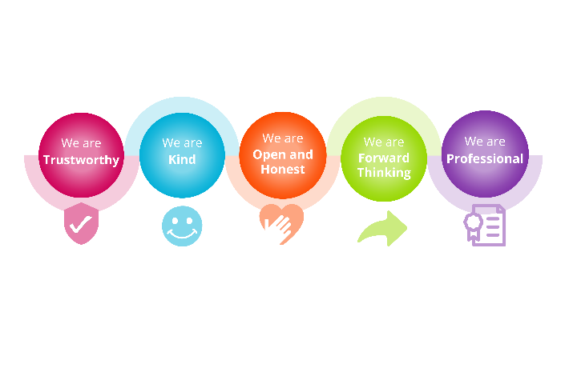

Our Values:
Our five values have clear descriptions and identified behaviours that demonstrate what they look like in practice.
We are Trustworthy
We build trust with the children, young people, and families we support – as well as our partners - by being dependable, reliable, and accountable in all that we do.
We are Kind
We understand and value the unique needs of the people that we support. Providing care and support with compassion and empathy.
We are Open & Honest
We foster an honest and open-minded culture and are transparent in both our decision making
and communication.
We are Forward Thinking
We are committed to providing the highest quality of care, constantly seeking new, collaborative, and creative ways to deliver our services– encouraging everyone to be ambitious and to achieve their goals.
We are Professional
Flexible and agile in our approach, we uphold the highest professional standards to meet the needs of our children, young people, and their families.
The behaviours are split into three levels which are intended to be relevant and consistent throughout various roles within Rose Road.
Behaviours:
Our five values have clear descriptions and identified behaviours that demonstrate what they look like in practice. The behaviours are split into three levels which are intended to be relevant and consistent throughout various roles within Rose Road.
Job Descriptions include the different levels of each behaviour required which should be demonstrated throughout recruitment processes and ongoing employment.
Full details of the behaviours can be found in the ‘Values Framework’ document contained within the recruitment pack.

